|  |  |  |
| --- | --- | --- |
|  | **Tugas**  **Machine Learning / B**  Jurusan Teknik Elektro Fakultas Sains dan Teknologi | |
| Nama | : Yogs Satria Nugraha Kusmayadi |
| NIM | : 1217070087 |
| Dosen | : Rinrin Nurmalasari,S.T.,M.T. |

**Latihan 1**

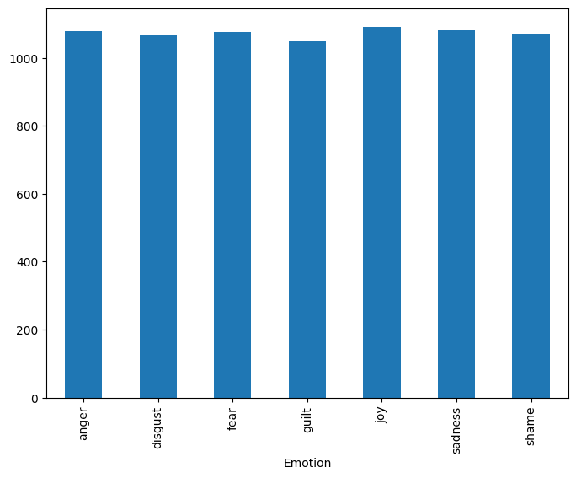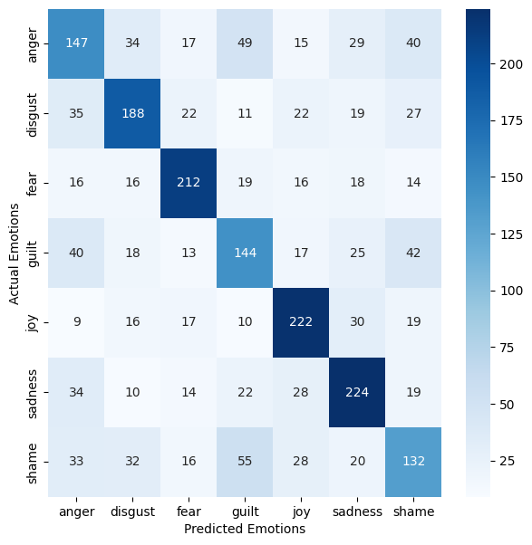

**Latihan 3**

